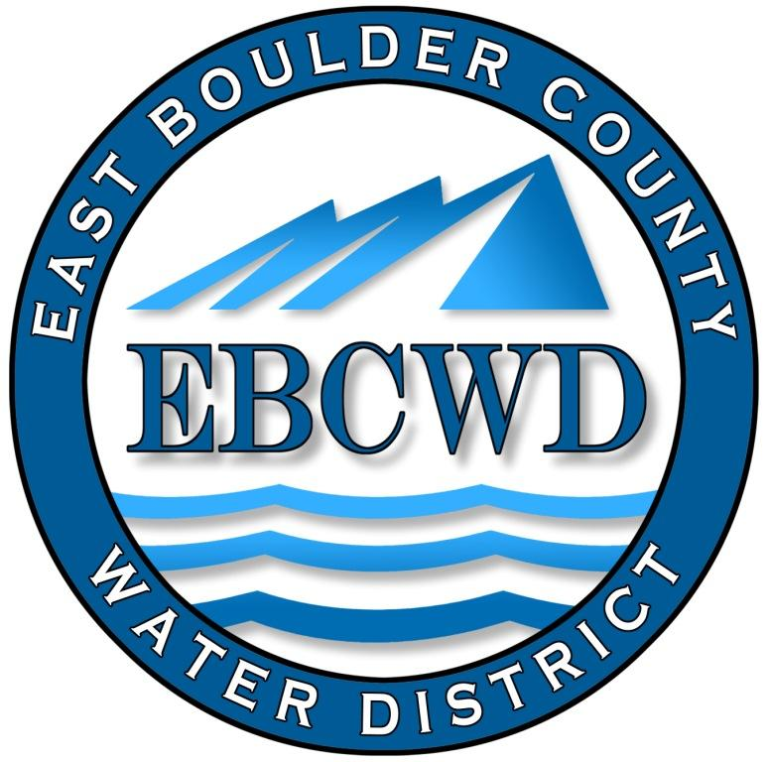
East Boulder County Water District
P.O. Box 18641, Boulder, Colorado 80308-1641
303.554.0031 www.eastboulderwater.com

Board of Directors Regular Meeting

Virtual Meeting Held with Zoom

10 October 2022

Mark Johns (President) called the meeting to order at 4:01 PM. Those in attendance via video were the board members Marsh Lavenue, Yvonne Gates and Bob Champ. Mary Wagner (Bookkeeper) and Peter O’Brien (Operations) were also present. Catherine Gee was absent (excused).

Public Comments
No members of the public joined the meeting.

Secretary’s Report
The minutes of the 12 September 2022 meeting were discussed.
Mark Johns suggested that we table approving the minutes so that they could more accurately address the FEMA response to the Marshall Fire, which will be discussed later in this meeting.

Reports from Consultants and Committees

Finance Report
Mary Wagner had e-mailed the financial packet to the board. The water usage spreadsheet was also e-mailed.
Mary noted that the payments from the damages incurred from the fire would not be treated as income and she will adjust the financial report accordingly. Mary also noted that $60k of our insurance reimbursement has not yet been spent. Last month the expense for Boulder Water Well was about $10k due to the fire and about $5k for system operations.
Interest on deposits has increased because of the rise in interest rates.
Mary went through the remaining financial statements and the board approved the financial statements and the transactions.

IT Report
The bill from Omni Network Designs was $150 for the month, which was for regular maintenance.
System Operations Report– 09/08/2022-09/29/2022
09/08/2022 | - (JR)Pump house check 0.81 mg per liter free
09/14/2022 | - (JR) Pump House check 0.74 milligrams per liter free
09/19/2022 | - (JR), (Alex), (Sam)Valve exercise
09/20/2022 | - (JR), (Alex)Valve exercise
09/21/2022 | - (JR)Pump House check 0.86 mg per liter free
09/28/2022 | - (JR)Pump House check 0.90 mg per liter free
09/29/2022 | - (JR)End of the month meter reads

System Operations Fire Report – 09/02/2022-09/29/2022

09/02/2022 | - (CV) Locate7487 Empire Dr  - (CV)Locate 7534 Skyway Ct.  - (CV)Locate 777 Panorama Ct.  - (CV)Locate 866 Paragon Dr.  - (CV)Locate 7305 & 7236 Spring Ct.
09/07/2022 | - (JR) Locate 7340 Empire Dr  - (JR)Locate 1025 Paragon Dr  - (JR)Investigated water loss at 7534 Skyway Ct.
09/11/2022 | - (JR)Locate 7538 Spring Drive
09/14/2022 | - (JR)Locate 7413 Spring Drive  - (JR)Locate 6 Benchmark  - (JR)Locate 7340, 7352, 7366, 7425, 7444, 7456, 7487 Empire Drive
09/19/2022 | - (JR)Locate 7387, 7482 Panorama
09/21/2022 | - (JR)hydrant flushing  - (JR)Locate 7580 Skyway Ct
09/26/2022 | - (JR)Locate 7249 Spring Dr.
09/28/2022 | - (JR)Locate 7394, 7413, 7420 Spring Drive
09/29/2022 | - (JR)Locate 555 Apollo  - (JR)Locate 7444 Empire Drive,  - (JR)Locate 0 Paragon, 1025 Paragon,  - (JR)Locate 7214 Spring Court  - (JR)Locate 7373 Spring Drive.
Monthly | - Office work from Dustin for locates, CDPHE communications, etc. for month of September

Peter discussed that when newly built homes are connected to our meters a backflow device must be connected. Mark and Peter will inspect to make sure the builder is doing it correctly. If an existing service line is used it must be tested and confirmed by CDPHE. Peter noted the difference between a device and method, with a method not requiring yearly inspections. Our backflow devices will be designed as a method and not require yearly inspections.

Unfinished Business
Marshall Fire
FEMA

FEMA has walked back on the $110k reimbursement on the meters saying it was reimbursed by our insurance. Mark has sent in our insurance paper work and we will have to wait for a final ruling from FEMA. There is a potential that FEMA may cover 5% of administrative costs due to the fire. This would include costs such as Boulder Water Well administrative costs, which have now run to about $10k. We will have to wait for these matters to be resolved by FEMA.

FEMA will not cover the cost of hydrants, which is on the order of $1k per hydrant or about $20k.

Mark is still pursuing the cost of flushing the hydrants, which has been denied by FEMA.

District Insurance

Marsh updated the board on the obtaining of an insurance quote from the SDA Property and Liability Pool. Peter has started a cost evaluation of the pump house replacement and other infrastructure costs. Marsh will check if an escalation clause will be in the quote. The quote should be received in about two weeks.

CDPHE

A commitment award plaque has been received from CDPHE and will be posted in the pump house. Peter and Mark are very deserving of the award.

New Business
Colorado Family and Medical Leave Insurance (FAMLI) Program
This item was tabled until next month’s meeting. Mary noted that the topic had to be placed on next month’s agenda.
Preliminary Budget for 2023/ Schedule 2023 Budge Hearing
Mary went through the draft budget and made changes where necessary. The budget will be e-mailed to the board and posted on the website. The notice of the budget hearing at next month’s regular meeting (14 November 2022) will be published in the Daily Camera.
.
Detached ADU’s: Separate Service
Mark is working with Lafayette to more fully understand their policy with respect to this matter. If an ADU requires a new tap it may have to be purchased by providing a share of Big Thompson Water (about $70K). Mark is trying to get clarification on what their policy is.

Directors Comments and Other Matters to Come Before the Board
Mark asked the board if it would be prudent if we contacted our attorney on Lafayette’s authority to dictate the ADU policy with respect to our IGA (Intergovernmental Agreement). The board agreed and Mark will contact our attorney.

Adjourn
A motion was made to adjourn by Mark Johns, seconded by Yvonne Gates and unanimously approved. The meeting was adjourned at 5:30 PM.
The secretary respectfully submits the above.
Robert Champ; 10/10/22

