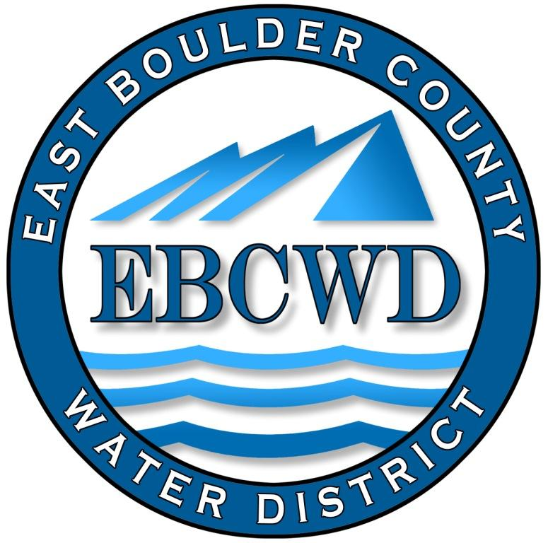
East Boulder County Water District
P.O. Box 18641, Boulder, Colorado 80308-1641
303.554.0031 www.eastboulderwater.com

Board of Directors Regular Meeting

Virtual Meeting Held with Zoom

12 July 2021

Mark Johns (President) called the meeting to order at 4:03 PM. Those in attendance via video were the board members Marsh Lavenue, Catherine Gee, Yvonne Gates and Bob Champ. Mary Wagner (Bookkeeper) and Peter O’Brien (Operations) were also present.

Public Comments
No members of the public were present.

Secretary’s Report
The minutes of the 14 June 2021 meeting were discussed. Marsh Lavenue made the motion that we approve the minutes of the 14 June 2021 meeting. Bob Champ seconded the motion, which was approved unanimously.

Reports from Consultants and Committees

Finance Report
Mary Wagner had e-mailed the financial packet to the board. The water usage spreadsheet was also e-mailed.
Mark noted that there was a discrepancy between our main meter reading and Lafayette’s reading. Mary noted that the meter reading could be a couple of weeks apart, thereby resulting in the discrepancy.
A resident that had higher than normal usage because of a leak had asked if there could be some adjustment in the water bill. It was decided that the amount of excess water used was at Lafayette’s top rate ($9.91/1k gallons) and no alleviation could be granted. Mark will call and explain to the customer.
Mary went through the financial statements and the board approved the financial statements and the transactions.

IT Report
Marsh reviewed the Omni work scope and noted that work was minimal (2 hours at $70/hr.).
The following was noted on Steve’s invoice:
June 2nd – Working on monthly Maintenance for East
Boulder Water. Had to visit the pumphouse in person again to
get the laptop on the remote network.

June 17th – Working with Pete to get his operations mailbox
setup on the new laptop. We used Mozilla Thunderbird for the
email client.

Catherine noted that items were posted on the website.
System Operations Report – 6/14/2021-7/09/2021
06/14/2021 | - Pete and Sam prep for repairing broken valve boxes (Dry run) with new tool.  - Arranged Warning Lights, submit insurance and apply for permit from Boulder County, pick up permit in Longmont
06/15/2021 | - Pete and Sam repair broken valve boxes at 7 locations, picked up extra cut-off discs, rentals, and supplies for the work.  - Generator Rental 7.5kw and Hammer Drilling/Chiseling Rental  - Cold patch asphalt repair with cutoff discs and black tar sealant
06/16/2021 | - Pete- Pump house check1.20 mg/l free, indicator lamp on pump #1 failed, power outage generator ran 4:37 a.m. till 8:25 a.m. multiple start/stops, found the VFD on the fire pump tripped for high bus voltage, found pump #2 off, low pressure alarms had been being sent out, but text messaging was never received, I didn't get alarm messages of low pressure~68 PSI at lowest point from 6-7am, set up email on laptop with Steve.  - Pete turned water on at 7217 Spring Ct
06/23/2021 | - Locate 7526 Spring Dr.  - Pete- Pump house check 1.06mg/l free, locate 7526 Spring Dr.  - Generator developed a leak, looks like it is the water pump, called to see if any warranty would apply due to it being changed in April of 2020, Generator Source said it would be 1 - 2 weeks, we should be able to do it by July 3rd.
06/28/2021 | - Locate 555 Apollo  - Refresh marks at 7217 Spring Ct. and at 7526 Spring Dr.
06/30/2021 | - Refilled the generator, and it was alarming for low coolant. Pete ordered water pump for generator and it should be in later this week.  - Meter reads  - Moved files from old computer to new computer. Contacted Census regarding problem with new computer having different com ports for admin vs operations.
07/03/2021 | - Replaced water pump on Generator
07/06/2021 | - Locate 7566 Skyway Ct and 7391 Spring Dr.  - Installed new indicator lamp on Pump # 1.
07/07/2021 | - Replaced batteries on CN66 Chlorine meter,  - Pump house Check 1.03MG/L Free  - Locate 7340 Empire.

Unfinished Business

Checking account signature authorizations
Mark has talked to the bank and those of us authorized as signatories will go to the branch on McCaslin Boulevard and get authorized as a signatory on our account.
Revision to Rule 8-1-7 Right of Way/Easement Violations
Mark had e-mailed the revised resolution to the board for their review. The board agreed with the revision.
Mark Johns made the motion that we approve Resolution 2021-3 amending Paragraph 8-1-7. Yvonne Gates seconded the motion, which passed unanimously.
Consumer Confidence Report
Yvonne noted that the CCR has been filed with the State.

New Business
No new business was discussed.

Directors Comments and Other Matters to Come Before the Board
No comments were noted.

Adjourn
A motion was made to adjourn by Yvonne Gates, seconded by Mark Johns and unanimously approved. The meeting was adjourned at 4:45 PM.
The secretary respectfully submits the above.
Robert Champ; 7/12/2021

