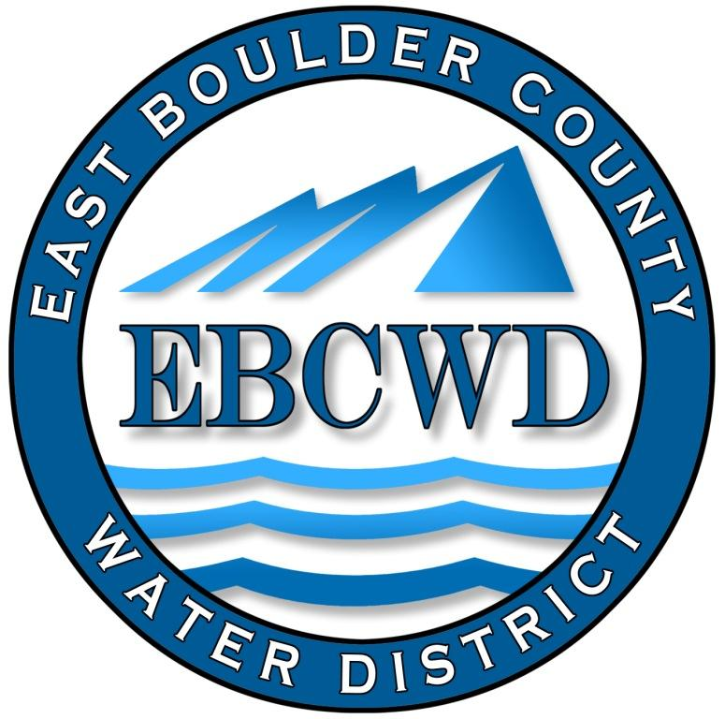
East Boulder County Water District
P.O. Box 18641, Boulder, Colorado 80308-1641
303.554.0031 www.eastboulderwater.com

Board of Directors Regular Meeting

Virtual Meeting Held with Zoom

10 May 2021

Mark Johns (President) called the meeting to order at 4:01 PM. Those in attendance via video were the board members Marsh Lavenue, Catherine Gee, Yvonne Gates and Bob Champ. Mary Wagner (Bookkeeper) and Peter O’Brien (Operations were also present.

Public Comments
No members of the public were present.

Secretary’s Report
The minutes of the 12 April 2021 meeting were discussed. Marsh Lavenue made the motion that we approve the minutes of the 12 April 2021 meeting. Mark Johns seconded the motion, which was approved unanimously.

Reports from Consultants and Committees

Finance Report
Mary Wagner had e-mailed the financial packet to the board. The water usage spreadsheet was also e-mailed.
Mary noted that a vacant lot on Skyway Ct. had sold and that a credit had been paid to the previous owners. The Audit Exemption has also been paid. The payment for the new website was also paid.
Mary went through the financial statements and the board approved the financial statements and the transactions.

IT Report
This is discussed under the website update.

System Operations Report –4/13/2021-5/10/2021
04/13/2021 | - Jay locate 1000 and 7526 Spring Dr..
04/14/2021 | - Pump House Check 0.94mg/l free.  - Locate 7509 Spring Dr and final read 962 Ponderosa Dr.
04/20/2021 | - Jay locate 509, 7217 and 7526 Spring Dr.
04/21/2021 | - Pump House Check 0.60mgl/free.
04/23/2021 | - Locate 7217 Spring Ct and 7302 Spring Ct.
04/28/2021 | - Pump House Check 0.78mgl/free .
04/30/2021 | - Meter Reads.  - Locate 7233 Spring Ct, 7481 Spring Dr, 7366 Empire Dr.
05/05/2021 | - Pump House Check 0.98mg/l free.  - Collect Sample 7788 Spring Dr. 0.78 mg/l free.

Peter noted that he swapped out two meters in the district. He also addressed flooding in a meter pit on Paragon Drive due to recent rains and ground water. Peter will notify Mark regarding when he can start work on replacing the valve sleeves in the street. Pete also elucidated the backflow prevention report to the state, which only refers to the pump house. Mark noted that there was some drywall damage in the pump house and he will see about getting this repaired.

Unfinished Business

Website Update
Marsh gave an update on Omni Network Design’s work during the last month. Steve will give us a written report summarizing this work and submitting an invoice on a monthly basis. The board thought that it was not necessary that Steve attend the meetings, except when needed.
Mark thought that it would be nice if the board could communicate via g-mail accounts and thought that Steve could set this up. Marsh will talk to Steve about this.
Catherine noted that the new website is up and that a link to the archived web site is available.

New Business
Revision to Rule 8-1-7 Right of Way/Easement Violations
Because of recent problems with the freezing of meters due to not being buried to the lid height, it was thought that we should revise the Rules and Regulations assuring that the meters in the district are appropriately insulated. We will post that we will address this at the next meeting.
Checking Account Signature Authorizations
Only Mark, Bob and Mary are currently authorized to sign checks at this time. It would be advantageous to have all the board members plus Mary be authorized to sign district checks.
Mark Johns made the motion that all board members (Mark Johns, Marsh Lavenue, Yvonne Gates, Catherine Gee and Robert Champ) and Mary Wagner be authorized to be on our checking account and thereby sign district checks. Yvonne Gates seconded the motion, which passed unanimously.
This motion when presented to the bank by Mary or a board member will allow them to be on the checking account. If a board member does not want to be on the account, they do not have to go to the bank and have their name on the account.
It was also noted that Mark, Mary and Bob are on the Colotrust Account and it was decided to leave this as is.

Boulder Water Well Price Increase
Boulder Water Well has raised its hourly rate from $95/hr. to $135/hr., effective immediately. Peter was excused so that the board could discuss this significant increase in the hourly rate.
Marsh thought that we could negotiate lower rates for tasks such as meter reading and locates. It was also thought that because this increase was presented to us in the middle of our fiscal year, we might be able to negotiate a phasing in of the price increase until the end of the year, whereby we could budget the higher increase.
Catherine also noted that we should verify that this rate is within the market rate for these types of services.
It was decided by the board that we should ask Boulder Water Well if they would accept a phasing in approach to the rate hike so that we could budget for the significant increase in the next year.
Marsh Lavenue made the motion that we offer to pay a rate of $115 /hr. until January 2022. In the meantime, Marsh will research the market rate for similar services and report to the Board before the end of the year so the Board can ascertain whether the $135/hr. rate is consistent with the market. The Board agreed to reconsider a second adjustment to BWW’s hourly fee after that research is completed. Catherine Gee seconded the motion, which passed unanimously.

Directors Comments and Other Matters to Come Before the Board
No other matters or comments were noted.

Adjourn
A motion was made to adjourn by Yvonne Gates, seconded by Marsh Lavenue and unanimously approved. The meeting was adjourned at 5:30 PM.
The secretary respectfully submits the above.
Robert Champ; 5/10/2021

