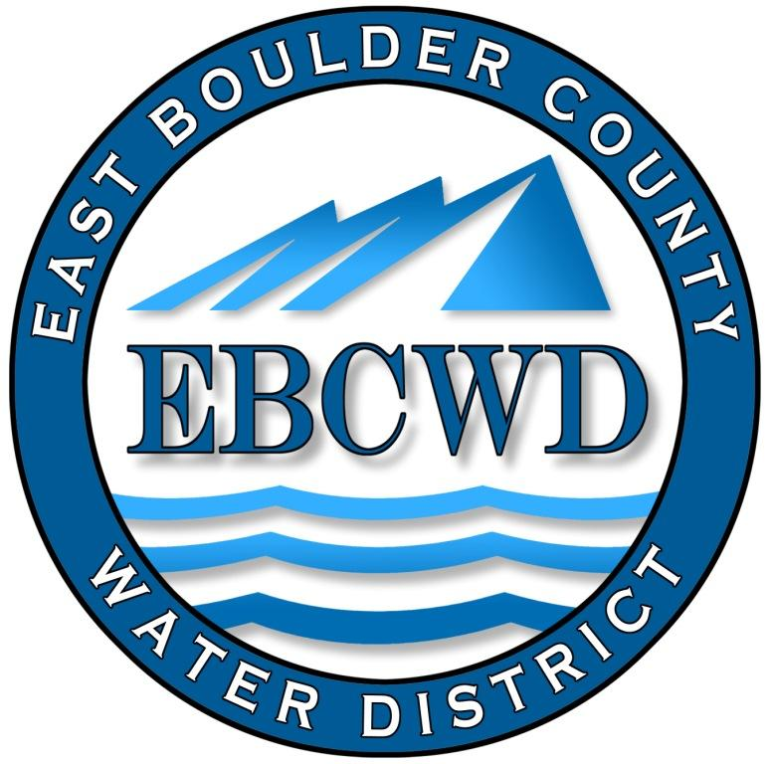
East Boulder County Water District
P.O. Box 18641, Boulder, Colorado 80308-1641
303.554.0031 www.eastboulderwater.com

Board of Directors Regular Meeting

Virtual Meeting Held with Zoom

13 December 2021

Mark Johns (President) called the meeting to order at 4:04 PM. Those in attendance via video were the board members Marsh Lavenue, Catherine Gee, Yvonne Gates and Bob Champ. Mary Wagner (Bookkeeper) and Peter O’Brien (Operations) were also present.

Public Comments
No members of the public were present.

Secretary’s Report
The minutes of the 8 November 2021 meeting were discussed. Mark Johns made the motion that we approve the minutes of the 8 November 2021 meeting. Yvonne Gates seconded the motion, which was approved unanimously.

Reports from Consultants and Committees

Finance Report
Mary Wagner had e-mailed the financial packet to the board. The water usage spreadsheet was also e-mailed.
Mary noted that 2 Benchmark had sold.
The budget will be forwarded to the state in January.
Mary went through the financial statements and the board approved the financial statements and the transactions.

IT Report
Minimal maintenance was done (1 hour).
Operations
System Operations Report – 11/10/2021-12/08/2021

11/10/2021 | - outline hydrant flushing  - pump house check 0.68mg/l free
11/12/2021 | - meet with Dominic Delgado, and Marsh Lavenue for sanitary survey
11/17/2021 | - locate 7271 Spring Ct.  - locate 7739 Spring Dr.  - pump house check 0.77mg/l free  - collect sample 7274 Spring Dr
11/26/2021 | - pump house check 0.71mg/l free
11/30/2021 | - meter reads  - Pump house check 0.68mg/l free
12/08/2021 | - certified collection of water sample at 1 Benchmark 0.53mg/l free,  - pump house check 0.68mg/l free  - locate 940 Paragon Dr.

Peter discussed his meeting with Mr. Delgado (State) on the 12th of November. It was noted that those residences with fire suppressing sprinkler systems must have a backflow device or method to prevent contamination of the water supply. Such devices or methods must be inspected or verified yearly. We will review our Rules and Regulations to see if this item is present and how we deal with it, as this will be a new responsibility for our operations staff. Also discussed was the inspection of the storage tank. We will now use the state form and continue the inspecting quarterly. Ultimately, a letter was received from the state noting no violations.
It was also noted that 940 Paragon was active as of 12/11/21.

Unfinished Business
No unfinished business was discussed.

New Business
Water Rate Hearing for 2022
Mark Johns made the motion that we open the water rate hearing. Marsh Lavenue seconded the motion, which passed unanimously.
The water rate hearing was noticed in the Daily Camera on November 2, 2021.
Marsh Lavenue had e-mailed rate adjustment scenarios to the board for discussion. Lafayette had increased their water rates for 5 straight years by 5% per year. The board did not pass on the last two years of this increase.
Because of the unusually wet spring and an accidental meter misread our water revenue for 2021 was low. This was taken into account in developing the 2022 budget. However, it was determined that we should keep a reserve of about $500K and to do this our water rates should cover our operating expenses. After much discussion, it was decided to use Marsh’s 5% across the board scenario for 2022. This would increase our water revenue by about $12k. We will then revisit our financial status at the end of 2022.
Mark Johns made the motion that we increase our water rates by 5% across the board for 2022. Bob Champ seconded the motion, which passed unanimously.
Mark Johns closed the water rate hearing.
Appointment of Designated Election Official
Mary Wagner kindly agreed to be the designated election official for the 2022 election. Mark Johns and Catherine Gee are both up for re-election in 2022. Mary will e-mail them the self-nomination forms should they decide to maintain their board positions.
Mary had the resolution document for appointing the designated election official.
Mark Johns made the motion that we pass the Resolution document appointing Mary Wagner as the Designated Election Official for the upcoming election on 3 May 2022, which will elect two board members for 3-year terms. Marsh Lavenue seconded the motion, which passed unanimously.
The resolution will be signed and Mary will handle it and the election appropriately.

Directors Comments and Other Matters to Come Before the Board
No comments were noted.

Adjourn
A motion was made to adjourn by Mark Johns, seconded by Yvonne Gates and unanimously approved. The meeting was adjourned at 5:28 PM.
The secretary respectfully submits the above.
Robert Champ; 12/13/2021

